**Ch26**

**2. Error Correction by RNA Polymerase**

In living cell, the conservation of DNA is more important than RNA. Because DNA is the template of RNA, also DNA would be replicated during the process of cell division. Changes on DNA will involve changes on all proteins expressed by the fragment of DNA. However, RNA is not so stable as DNA. Mutations on single chain of RNA cause changes on limited amount of protein, and then the mutated RNA would be degraded.

**3. RNA Posttranscriptional Processing**

AAUAAA is the signal of poly(A) addition, hence mutation to this sequence is may cause the deficiency of poly(A) tail that involves the half-life of RNA. So the mutation may make RNA easier to be degraded.

**6. The Chemistry of Nucleic Acid Biosynthesis**

Common:

a. Use triphosphaylated compound as the material.

b. From 5’ to 3’

c. Template demanded

d. Bases are complementary paired.

Polynucleotide phosphorylase:

Similarity: From 5’ to 3’

Difference:

Template independent

Use NDP as the material

**9. RNA Genomes**

Reverse transcriptase and RNA replicase contain no proofread activity. In this case, the frequency of mutation is much higher than DNA genome, hence small genome can lower the number of mutations.

**11. Slow Death**

Although the toxin block RNA transcription as soon as they enter nuclear, some essential mRNA can still play their roles in cytosol. As time passing, these RNA are degraded, hence some important proteins can’t be expressed and cell couldn’t work normally.

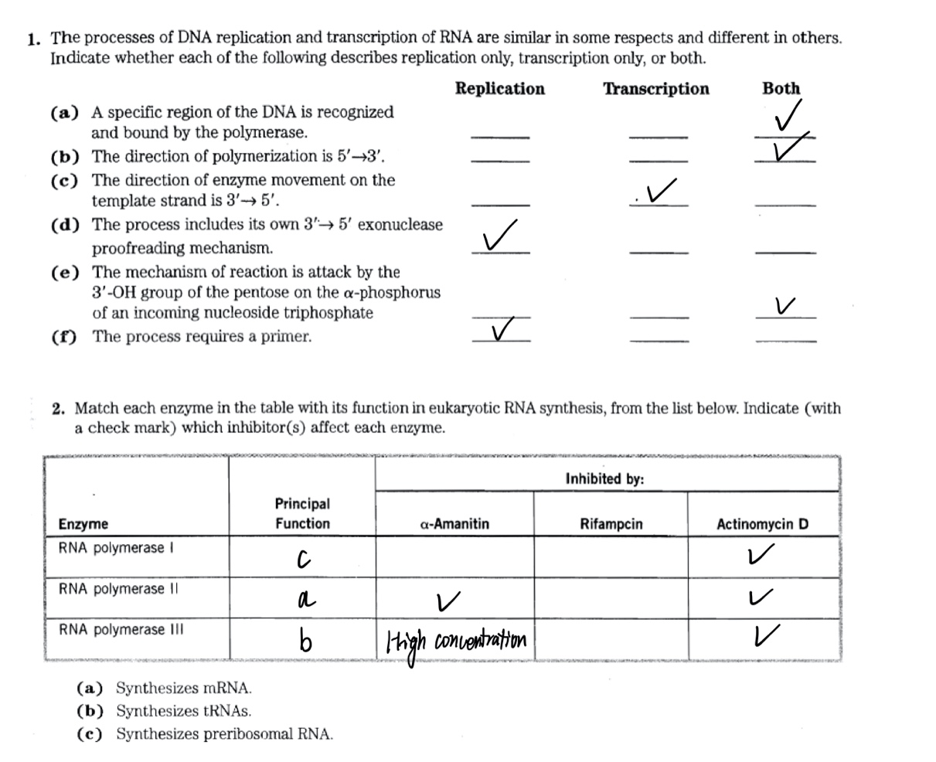**Extra Question**